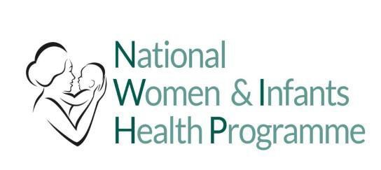

**Reporting of Incidents associated with Cardiotocography (CTG) devices**

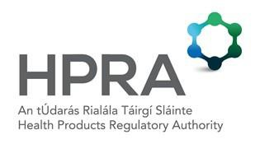

The Health Products Regulatory Authority (HPRA) is the competent authority for medical devices in Ireland. As part of this role a medical devices vigilance system is maintained to protect the health and safety of patients, users and others. This is achieved through the evaluation of vigilance reports from manufacturers, users and others, by providing information to users on the safe use of medical devices and where appropriate, through the evaluation of market actions e.g. medical device recall or modification.

The HPRA requests that users submit a user report for any malfunction or deterioration in the characteristics and/or performance in the medical devices that you use, as well as any inadequacy in the labelling or the instructions for use which might lead to or might have led to the death of a patient or user or to a serious deterioration in their state of health*.* The HPRA is also interested in being notified of any usability issues that you have noted that may influence the effective and safe use of a medical device.

**In particular, in the area of Cardiotocography (CTG) medical devices that are used in obstetrics services in Ireland, the HPRA is interested in receiving vigilance reports of any incidents where it is felt that the device may have contributed or could contribute (should an issue recur) to a negative clinical outcome (i.e. death or to a serious deterioration in their state of health) for the mother or the baby. Reports should be submitted regardless of the clinical outcome. This could include an inadequacy in the labelling or instructions for use of the device.**

We request that users consider reporting the following;

Shortcomings in the device performance or interface that, despite interpretation of the CTG trace by a trained and competent user, may have led to clinical abnormalities not being appreciated.



Any concerns that the CTG monitor may not have recorded the maternal or foetal traces accurately, in the absence of maternal factors known to contribute to altered CTG trace quality e.g. maternal obesity.



Any unexpected adverse outcomes where there is suspicion that device malfunction may have been a contributory factor.



A feature of monitors which, in certain situations, increase rather than decrease the possibility of human error



Any concerns raised about monitors following the review of an adverse event.



When submitting a user report to the HPRA, factors such as the following may be considered:

An audible / visual foetal heart rate (FHR) output that differs from the printed FHR trace.



Situations where re-establishing FHR monitoring after transducer repositioning has been unduly delayed or may have contributed to an adverse outcome



In a twin (multiple) pregnancy, interpreting one foetal heart as both (multiple) foetal heart rates.



Artefactual detection or display of FHR can occur for the reasons listed below: Displayed FHR is half of the true FHR as detected by auscultation.



Displayed FHR is double the true FHR as detected by auscultation. Misidentification of FHR and Maternal HR.



Please note, some devices offer ‘coincidence detection’, either via separate maternal monitoring or via alternative methods. Where ‘coincidence detection’ is being used, the above potential artefactual errors should be identified and alerted to the user. In situations where these alerts were not adequate, you should consider submitting a report to the HPRA.

To submit a report, please visit our [reporting device safety issues for healthcare professionals webpage](https://www.hpra.ie/safety-information/how-we-monitor-safety/medical-devices/reporting-safety-issues-for-devices/reporting-device-safety-issues-for-healthcare-professionals).

This guidance has been developed jointly by the National Women and Infants Health Programme and the HPRA