Package leaflet: Information for the user

Efluelda suspension for injection in pre-filled syringe
Trivalent influenza vaccine (split virion, inactivated), 60 micrograms HA/strain

Read all of this leaflet carefully before you are vaccinated because it contains important information for you.
- Keep this leaflet. You may need to read it again.
- If you have any further questions, ask your doctor, pharmacist or nurse.
- This vaccine has been prescribed for you only. Do not pass it on to others.
- If you get any side effects, talk to your doctor, pharmacist or nurse. This includes any possible side effects not listed in this leaflet. See Section 4.

What is in this leaflet

- What Efluelda is and what it is used for
- What you need to know before you use Efluelda
- How to use Efluelda
- Possible side effects
- How to store Efluelda
- Contents of the pack and other information

- What Efluelda is and what it is used for

Efluelda is a vaccine. This vaccine helps to protect persons of 60 years of age and older against influenza (flu). The use of Efluelda should be based on official recommendations on vaccination against influenza.

When a person is given Efluelda, the immune system (the body’s natural defence system) will produce its own protection (antibodies) against the disease. None of the ingredients in the vaccine can cause flu.

Flu is a contagious respiratory illness caused by influenza viruses, which can result in mild to severe illness, and could result in serious complications such as pneumonia, which can lead to hospitalization or even death. Flu is a disease that can spread rapidly and is caused by different types of strains that can change every year. Due to this potential change in circulating strains on a yearly basis, as well as the duration of protection intended by the vaccine, vaccination is recommended every year. The greatest risk of catching flu is during the cold months between October and March. If you were not vaccinated in the autumn, it is still sensible to be vaccinated up until the spring since you run the risk of catching flu until then. Your doctor will be able to recommend the best time to be vaccinated.

Efluelda is intended to protect you against the three strains of virus contained in the vaccine about 2 to 3 weeks after the injection. In addition, if you are exposed to flu immediately before or after your vaccination, you could still develop the illness as the incubation period for flu is a few days.

The vaccine will not protect you against the common cold, even though some of the symptoms are similar to flu.

- What you need to know before you use Efluelda

To make sure that Efluelda is suitable for you, it is important to tell your doctor or pharmacist if any of the points below apply to you. If there is anything you do not understand, ask your doctor or pharmacist to explain.

Do not use Efluelda:
- if you are allergic to:
- the active substances, or
- any of the other ingredients of this vaccine (listed in Section 6), or
- any component that may be present in very small amounts such as eggs (ovalbumin, chicken proteins) and formaldehyde.

Warnings and precautions
Talk to your doctor, pharmacist or nurse before using Efluelda.
You should tell your doctor before vaccination if you have:
- a poor immune response (immunodeficiency or taking medicines affecting the immune system),
- bleeding problem or bruising easily,
- experienced Guillain-Barré syndrome (GBS) (severe muscle weakness) after getting a flu vaccine.
- if you have an illness with a high or moderate temperature or an acute illness, the vaccination should be postponed until after you have recovered.
Your doctor will decide if you should receive the vaccine.

Fainting can occur following, or even before, any needle injection. Therefore tell your doctor or nurse if you fainted with a previous injection.

As with all vaccines, Efluelda may not fully protect all persons who are vaccinated.

If, for any reason, you have a blood test within a few days following a flu vaccination, please tell your doctor. This is because false positive blood test results have been observed in a few patients who had recently been vaccinated.

Children
This vaccine should not be used in children, it is only for use in adults aged 60 and older.

Other medicines and Efluelda
Tell your doctor or pharmacist if you are receiving, have recently received or might receive any other vaccines or any other medicines.
- If Efluelda is to be given at the same time as other vaccines, the vaccines should always be administered by using separate limbs.
- It should be noted that the adverse reactions may be intensified by any co-administration.
- The immunological response may decrease in case of immunosuppressant treatment, such as corticosteroids, cytotoxic drugs or radiotherapy.

Pregnancy and breast-feeding
Efluelda is only indicated for use in adults aged 60 years and older.
If you are pregnant or breast-feeding, think you may be pregnant or are planning to have a baby, ask your doctor or pharmacist for advice before using this vaccine. Your doctor/pharmacist will help you decide if you should receive Efluelda.

Driving and using machines
Efluelda has no or negligible influence on the ability to drive or use machines. However, if you are feeling unwell or dizzy it is not wise to drive.

Efluelda contains sodium
This medicine contains less than 1 mmol sodium (23 mg) per dose, i.e. essentially ‘sodium-free’.

- How to use Efluelda

Adults aged 60 years and over receive one 0.5 ml dose.

How Efluelda is given
Your doctor, pharmacist or nurse will administer the recommended dose of the vaccine as an injection into the muscle or under the skin.

If you have any further questions on the use of this product, ask your doctor or pharmacist.

4. Possible side effects

Like all medicines, this vaccine can cause side effects, although not everybody gets them.

Allergic reactions
See a doctor IMMEDIATELY if you experience:
- Severe allergic reaction
      - that may lead to medical emergency with low blood pressure, shortness of breath, wheezing or trouble breathing, rapid heart rate and weak pulse, cold, clammy skin, dizziness, that may lead to collapse (anaphylaxis [including angioedema, i.e. swelling most apparent in the head and neck, including the face, lips, tongue, throat or any other part of the body and which may cause difficulty in swallowing or breathing]).

See a doctor if you experience:
      - Allergic reactions such as skin reactions that may spread throughout the body including itching, hives, rash.
These side effects are rare (may affect up to 1 in 1,000 people).

Other side effects reported

The below side effects were reported in adults 60 years of age and older.

Very common (may affect more than 1 in 10 people)
- Reactions at the injection site: pain, redness (erythema)
- Generally feeling unwell (malaise), headache, muscular pain (myalgia)

Common (may affect up to 1 in 10 people):
- Reactions at the injection site: swelling, bruising, hardness (induration)
- Fever, chills (shivering)

Uncommon (may affect up to 1 in 100 people):
- Reactions at the injection site: pruritus
- Fatigue, lethargy, feeling sick (nausea), vomiting, diarrhoea
- Cough, muscle weakness, indigestion (dyspepsia), inflammation of the throat (oropharyngeal pain)

Rare (may affect up to 1 in 1000 people):
- Abnormal lack of energy (asthenia), flushing, joint pain (arthralgia), dizziness, night sweats, rash, numbness or pins and needles sensation (paraesthesia), inflammation of the nose (rhinorrhoea), vertigo, excess of blood in the white of the eye (ocular hyperaemia)
- Pain in extremities

Not known: frequency cannot be estimated from the available data
- Reduction in the number of certain types of particles in the blood called platelets; a low number of these can result in excessive bruising or bleeding (thrombocytopenia)
- Swelling of the glands in the neck, armpit or groin (lymphadenopathy)
- Neurological disorders that may result in stiff neck, confusion, numbness, pain and weakness of the limbs, loss of balance, loss of reflexes, paralysis of part or all the body (encephalomyelitis and transverse myelitis, brachial neuritis, Guillain-Barré Syndrome), facial palsy (Bell’s palsy), vision disorders due to the optic nerves dysfunction (optic neuritis/neuropathy), fits (convulsions including febrile convulsions), fainting (syncope) shortly after vaccination
- Blood vessel inflammation (vasculitis) which may result in skin rashes and in very rare cases in temporary kidney problems, blood vessel opening (vasodilatation)
- Chest pain
- Wheezing, throat tightness, difficulty breathing (dyspnoea)

Most side effects usually occurred within the 3 days following vaccination, and resolved within 3 days. The intensity of these side effects was mild to moderate.

Reporting of side effects
If you get any side effects, talk to your doctor, pharmacist or nurse. This includes any possible side effects not listed in this leaflet. You can also report side effects directly via HPRA Pharmacovigilance Website: www.hpra.ie. By reporting side effects, you can help provide more information on the safety of this medicine.

5. How to store Efluelda

Keep this vaccine out of the sight and reach of children.

Do not use this vaccine after the expiry date which is stated on the label and carton after EXP. The expiry date refers to the last day of that month.

Store in a refrigerator (2 °C – 8 °C). Do not freeze. Keep the syringe in the outer carton in order to protect from light.

Do not throw away any vaccines via wastewater or household waste. Ask your pharmacist how to throw away vaccines you no longer use. These measures will help protect the environment.

6. Contents of the pack and other information

What Efluelda contains

- The active substances are: Influenza virus (inactivated, split) of the following strains*:

A/Victoria/4897/2022 (H1N1)pdm09-like strain
(A/Victoria/4897/2022, IVR-238)..………………………………………………..60 micrograms HA**

A/Croatia/10136RV/2023 (H3N2)-like strain
(A/Croatia/10136RV/2023, X-425A) ..……………………………………………60 micrograms HA**

B/Austria/1359417/2021-like strain
(B/Michigan/01/2021, wild type)………………………………………………….60 micrograms HA**

Per 0.5 ml dose
* propagated in embryonated chicken eggs
** haemagglutinin

This vaccine complies with the WHO (World Health Organisation) recommendations (Northern Hemisphere) and EU decision for the 2025/2026 season.

The other ingredients are: a buffer solution containing sodium chloride, monobasic sodium phosphate, dibasic sodium phosphate, water for injections and octoxinol-9.

Some components such as eggs (ovalbumin, chicken proteins) or formaldehyde may be present in very small amounts (see Section 2).

What Efluelda looks like and contents of the pack

The vaccine, after shaking gently, is a colourless opalescent liquid.

Efluelda is a 0.5 ml suspension for injection presented in a pre-filled syringe (Suspension for injection) with or without needle (in box of 1, 5 or 10) or with safety needle (in box of 1 or 10). Not all pack sizes may be marketed.

Marketing Authorisation Holder and Manufacturer

The Marketing Authorisation Holder is:
Sanofi Winthrop Industrie
82 avenue Raspail
94250 Gentilly
France

The distributor is:
sanofi-aventis Ireland T/A SANOFI
Citywest Business Campus
Dublin 24
Ireland
Tel: +353 (0) 1 4035 600

The Manufacturer is:
Sanofi Winthrop Industrie
Voie de l’Institut
Parc Industriel d'Incarville B.P 101
27100 Val de Reuil
France

This medicinal product is authorised in the Member States of the EEA under the following names:

Austria, Belgium, Bulgaria, Czech Republic, Germany, Denmark, Estonia, Finland, France, Croatia, Hungary, Iceland, Ireland, Italy, Latvia, Lithuania, Luxembourg, Malta, the Netherlands, Norway, Poland, Portugal, Romania, Sweden, Slovenia, Slovakia, Spain | Efluelda
Cyprus, Greece | Efluelda TIV

This leaflet was last revised in 11/2025

-----------------------------------------------------------------------------------------------------------------------

The following information is intended for healthcare professionals only:

As with all injectable vaccines, appropriate medical treatment and supervision should always be readily available in case of an anaphylactic reaction following the administration of the vaccine.
The vaccine should be allowed to reach room temperature before use.
Shake before use. Inspect visually prior to administration.
The vaccine should not be used if foreign particles are present in the suspension.
It should not be mixed with other medicinal products in the same syringe.
This vaccine is not to be injected directly into a blood vessel.

See also Section 3. How to use Efluelda

˂Preparation for Administration
Instructions for use of safety needle with Luer Lock pre-filled syringe:
Picture A: Safety Needle (inside case) | Picture B: Safety Needle Components (prepared for use)
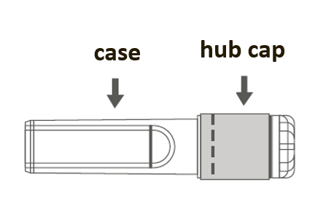 | 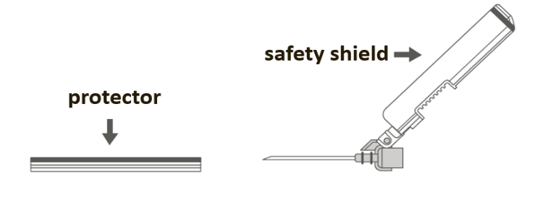

Step 1: To attach the needle to the syringe, remove the hub cap to expose the hub of the needle, and gently twist the needle into the Luer Lock adapter of the syringe until slight resistance is felt.
Step 2: Pull the safety needle’s case straight off. The needle is covered by the safety shield and protector.
Step 3:  A: Move the safety shield away from the needle and toward the syringe barrel to the angle shown. B: Pull the protector straight off. |  | 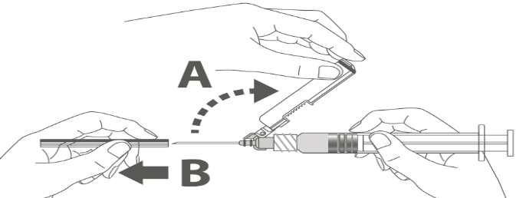
Step 4: After injection is complete, lock (activate) the safety shield using one of the three (3) one-handed techniques illustrated: surface, thumb or finger activation.  Note: Activation is verified by an audible and/or tactile “click.” |  | 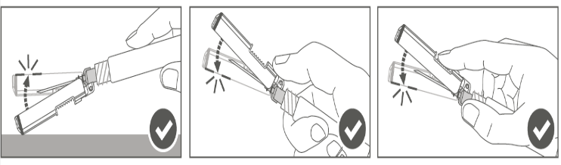
Step 5: Visually inspect the safety shield activation. The safety shield should be fully locked (activated) as shown in Figure C.  Figure D shows the safety shield is NOT fully locked (not activated). | 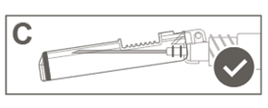  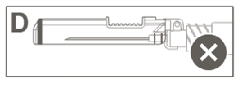
Caution: Do not attempt to unlock (deactivate) the safety device by forcing the needle out of the safety shield.

Any unused medicinal product or waste material should be disposed of in accordance with local requirements.˃

